Online Visa Application Guide for a Visitor (subclass 600) Business Stream Visa.

How to lodge an application:
Visa applicants must apply for the Visitor (subclass) 600 visa electronically through the Department of Home Affairs’ (Home Affairs) ImmiAccount portal. This is the single point of entry into the Home Affairs’ online visa services.

What information is required?:
Visa applicants must provide the following information about themselves:
- personal details from their passport
- contact/address information
- current employment details
- previous travel to Australia
- adequate health insurance coverage whilst in Australia
- how they will be supported financially whilst in Australia
- health and character declarations
- any other countries they have resided in.

It is critical to the success of your visa application that you answer all questions on the application form and supply all the requested supporting documents. Failure to do so could result in a significant delay or refusal of the visa application.

Important – visa lodgement:
It is strongly recommended that applicants apply 6-8 weeks of their intended travel dates of travel to ensure timely visa processing.
Home Affairs cannot guarantee that a visa will be finalised in time for the event if there are delays in lodging an application for a subclass 600 Visitor visa, or where an applicant does not respond to a request for further information in a timely manner.

Step 1 – Log into your ImmiAccount

Log into your ImmiAccount, and click on ‘New application’

Step 2 – Applying for a Visitor Visa subclass 600

Click on ‘New application’
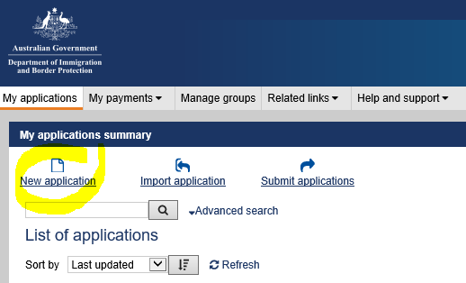

Select ‘Visitor’ then select ‘Visitor Visa (600)’

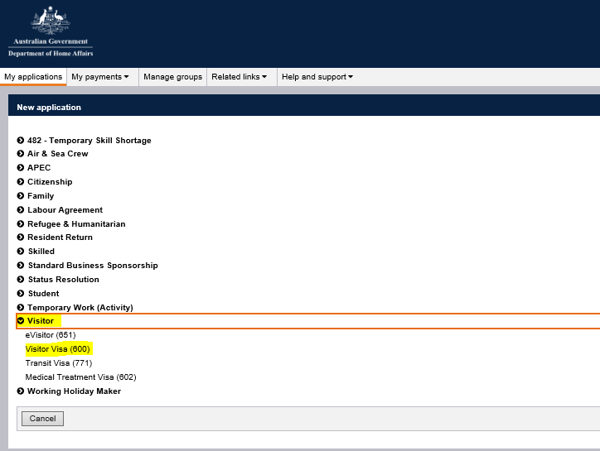

Select the checkbox to indicate that you accept the terms and conditions and click next
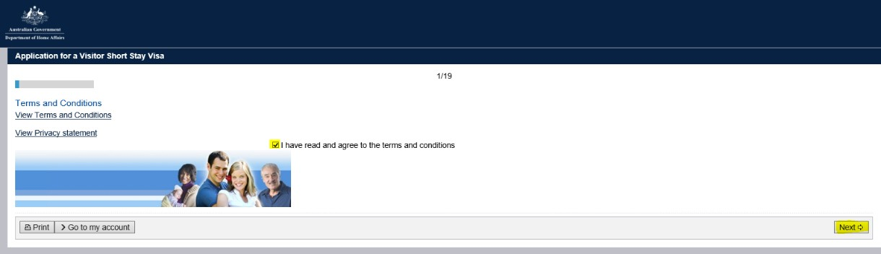

Application Context page:

This is the first page of the Visitor Visa (subclass 600) online form, and helps direct the rest of the form.

Through this page, visa applicants provide important pieces of information about their travel plans including information about travel dates and reason for travel to Australia
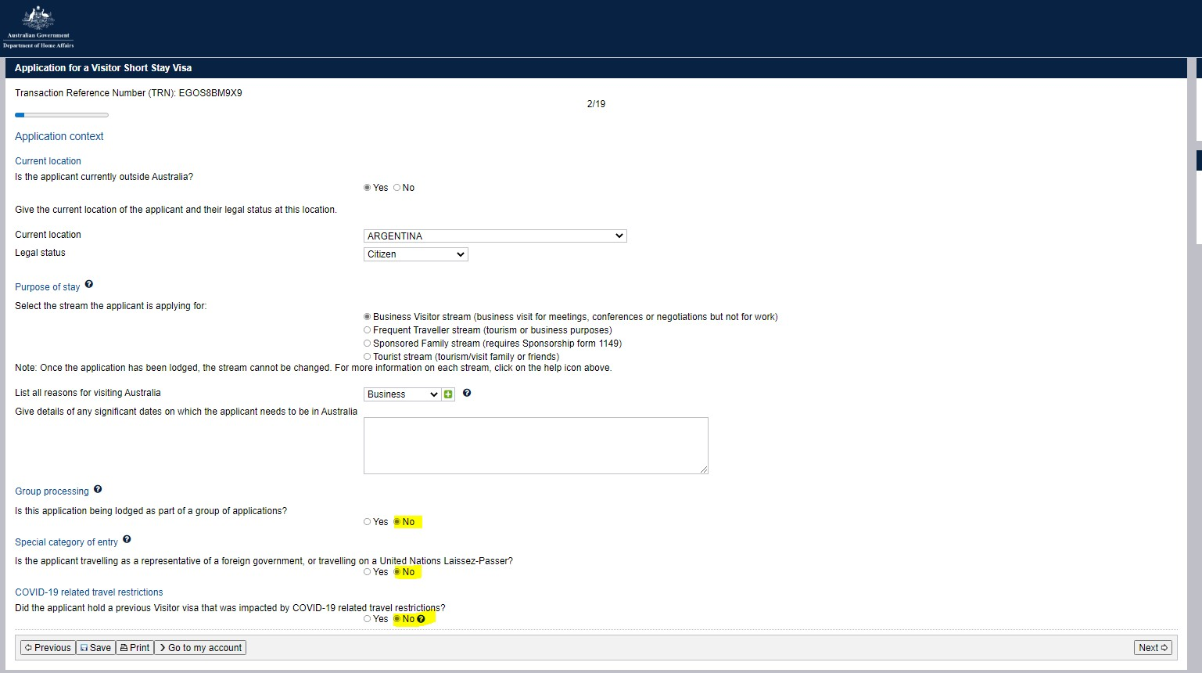

Applicant’s information page:
Applicant to complete details (per their passport bio-data page).

Applicant’s information page:
Applicant to complete details (per their passport bio-data page).
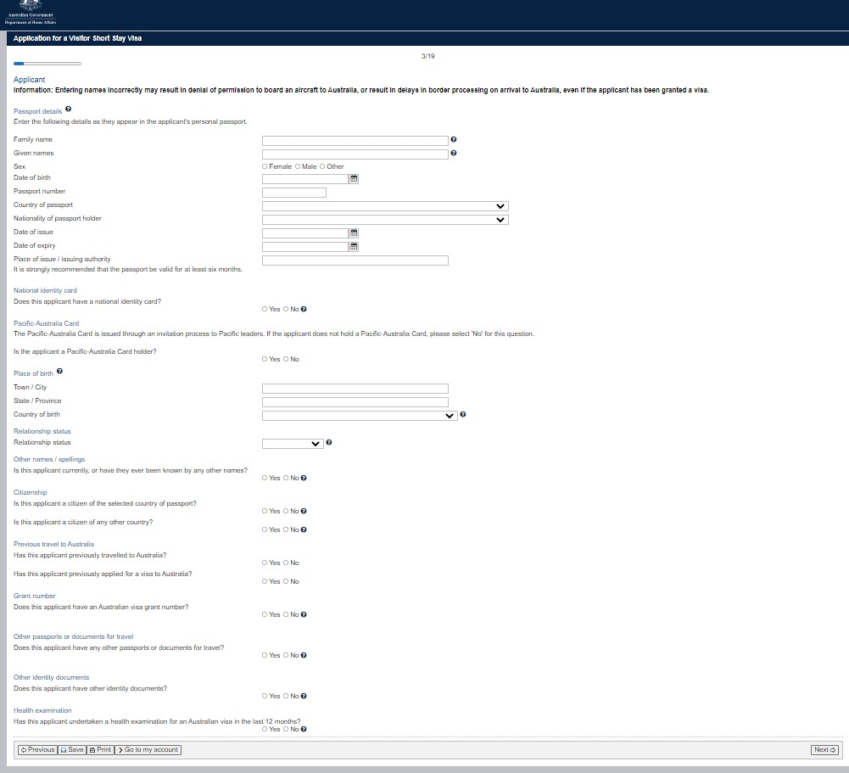

Critical data confirmation page:
Applicant to confirm information entered is correct
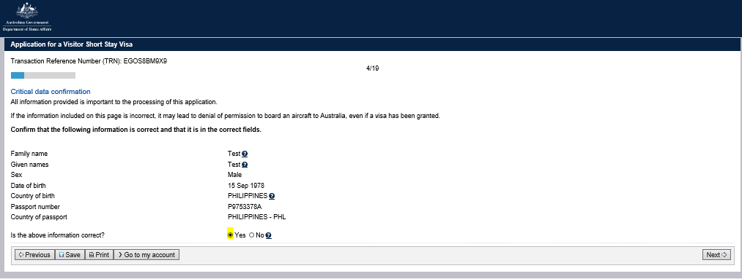

Travelling companion’s page:
If travelling with other person applicant to list each person travelling with them by clicking the ‘Add’ button.
Note: Each person travelling to Australia must submit a separate visitor visa application. This includes children and other family members. Listing a person’s name on this page does NOT mean that the person has applied for a visa.

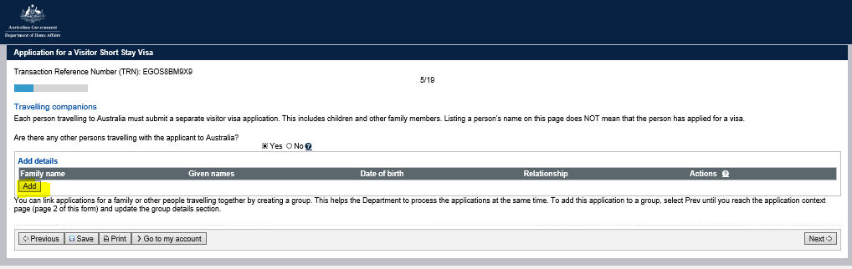

Contact information page:
Applicant to provide their contact details
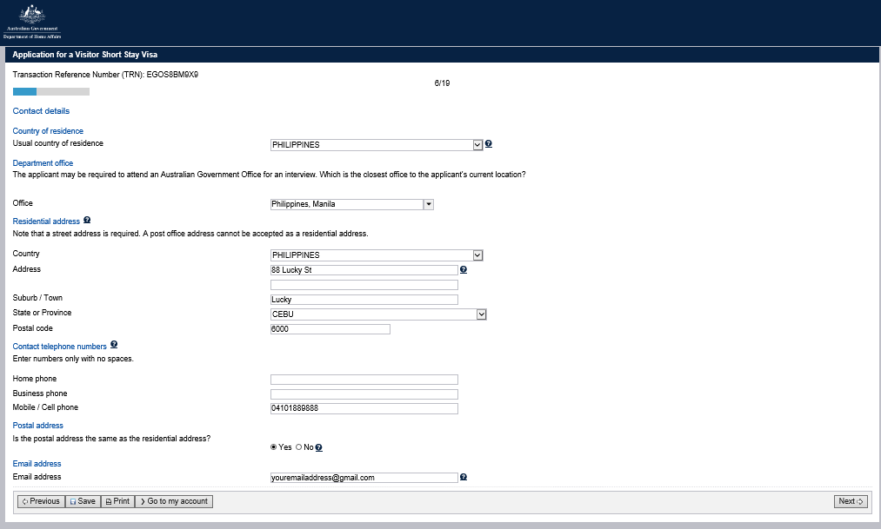

Authorised recipient page:
Applicant to provide details of authorise recipient if any
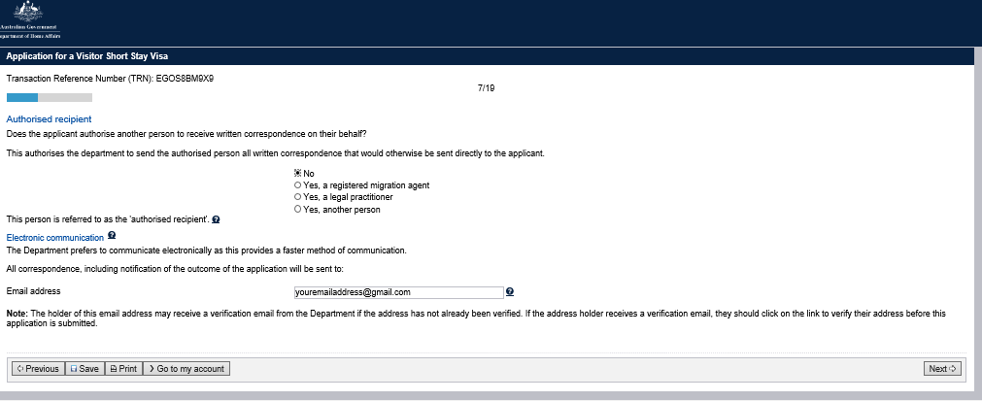

Non-accompanying members of the family unit page:
Applicant to list all members of their family unit who are not travelling to Australia.
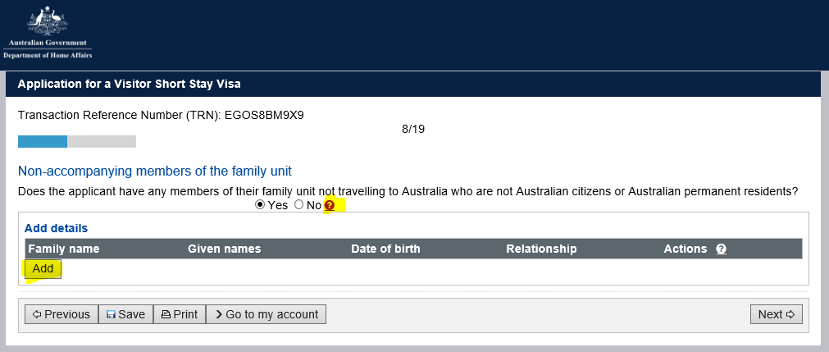

Entry to Australia:
Applicant to provide details of proposed period of stay in Australia
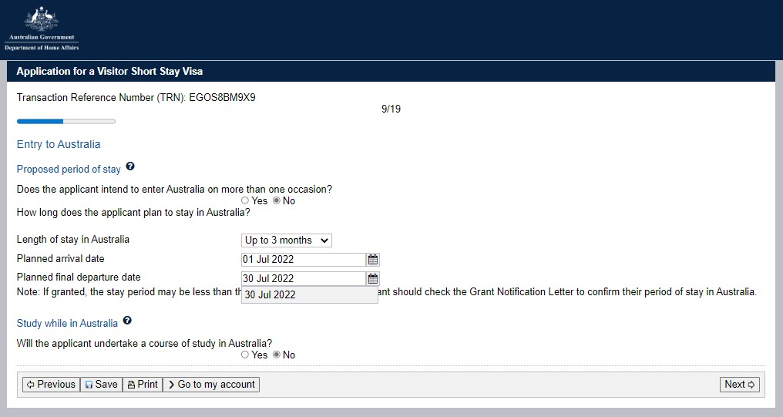

Visa applicant’s current overseas employment:

Applicant to provide details of their overseas employment
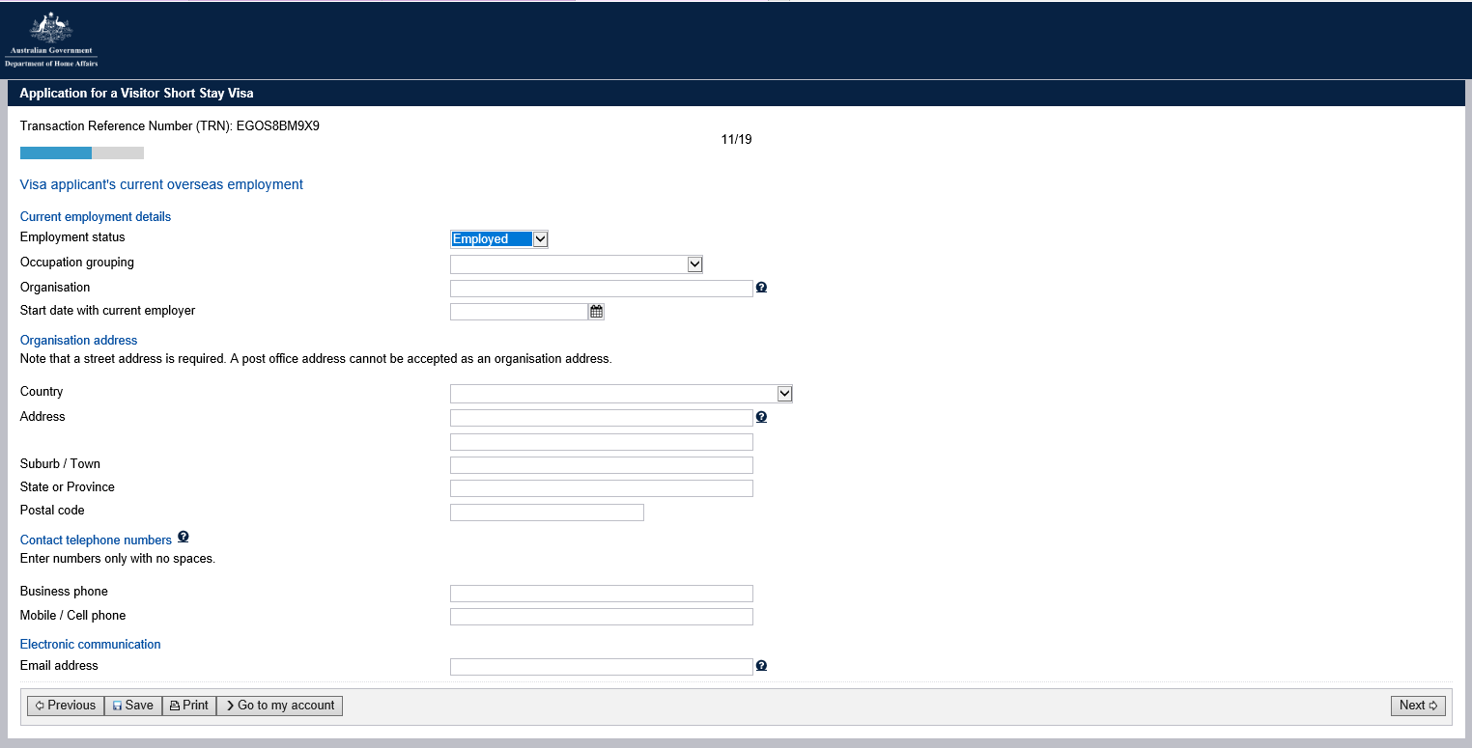

Financial Support:

Applicant to provide details of how their stay in Australia will be funded.
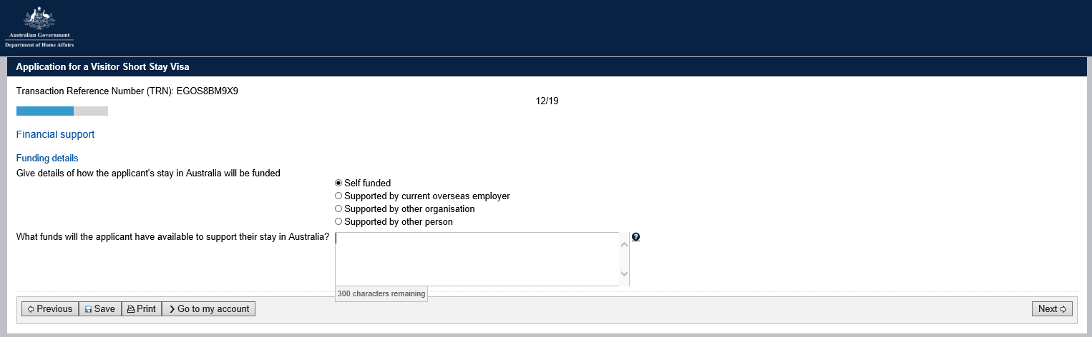

Business Activities:

Applicant to provide details of proposed business activity in Australia.
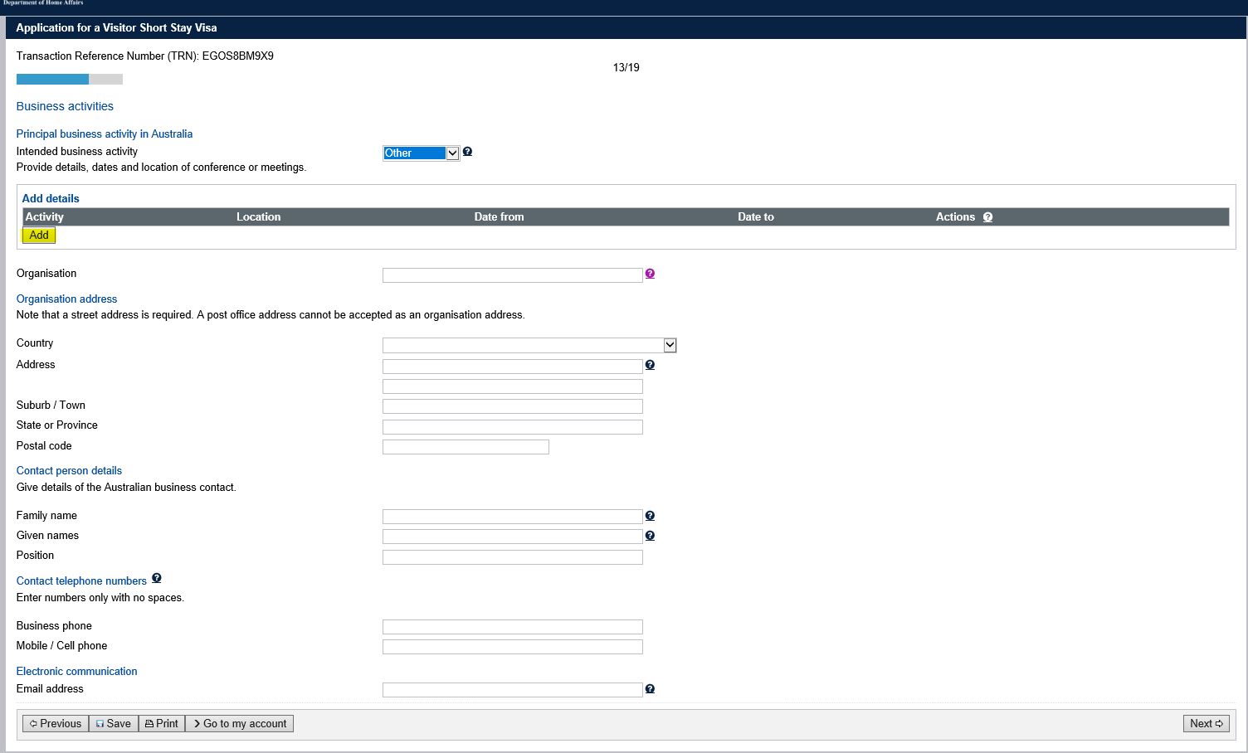

Applicants may provide the event organisers details on this page, even if it is an overseas event organiser.

Declaration pages:

The declaration pages require a ‘Yes’ or ‘No’ response to each question. You need to read each declaration carefully and respond according to each visa applicant’s personal circumstances.

Health declarations:
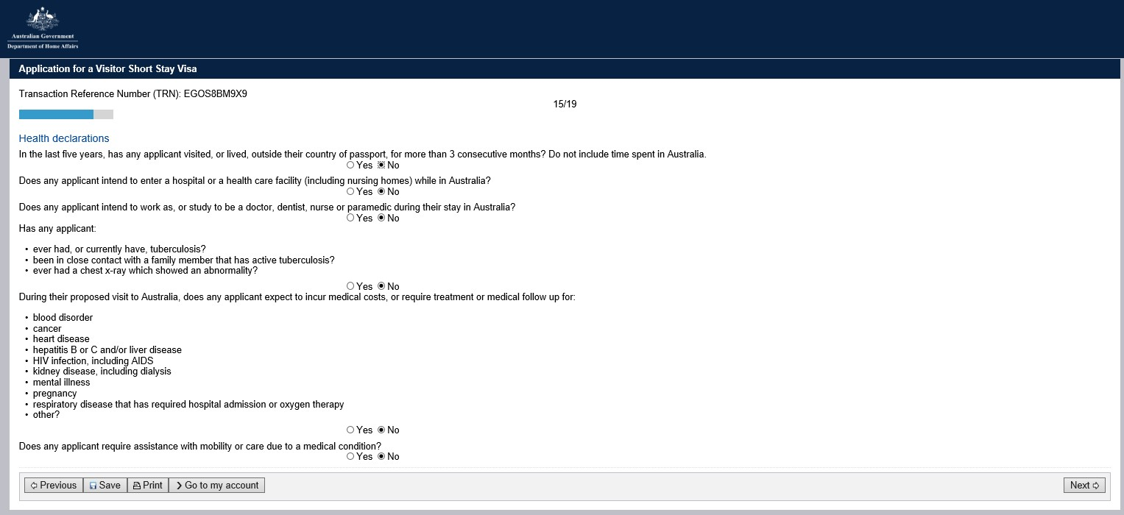

Character declarations:
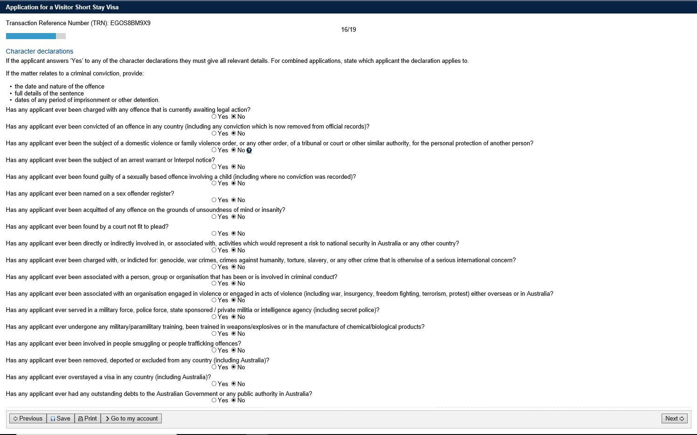

Visa history:
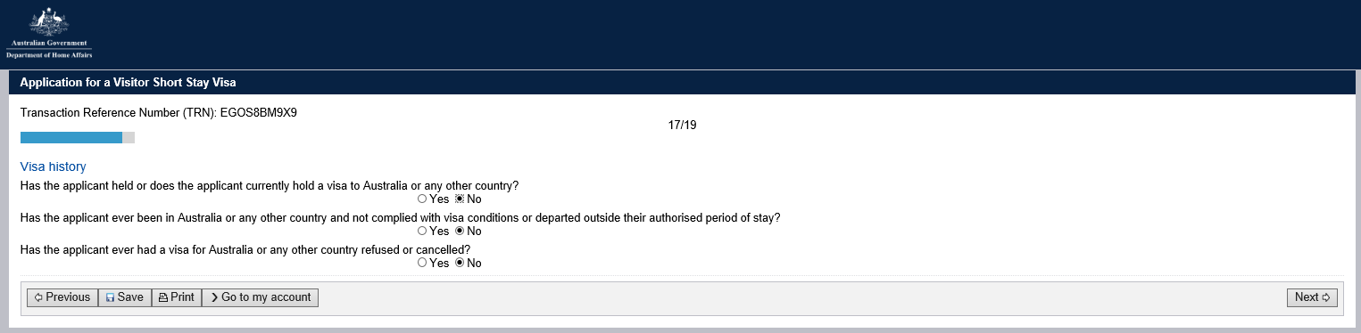

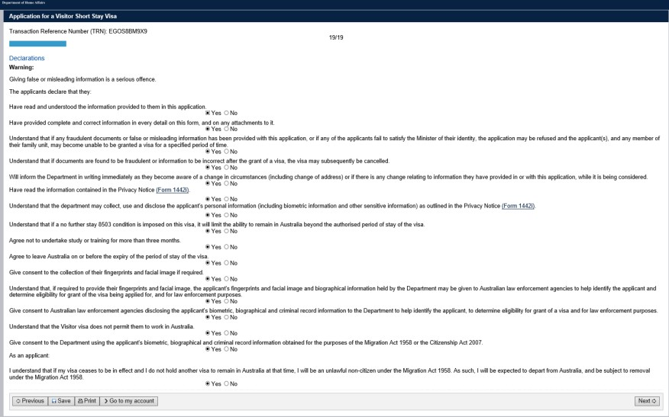

Applicants must ensure to attach required documents as indicated below. Instructions on how to attach documents to the visa application can be found via the following link: https://immi.homeaffairs.gov.au/help-support/applying-online-or-on-paper/online#content-index-2

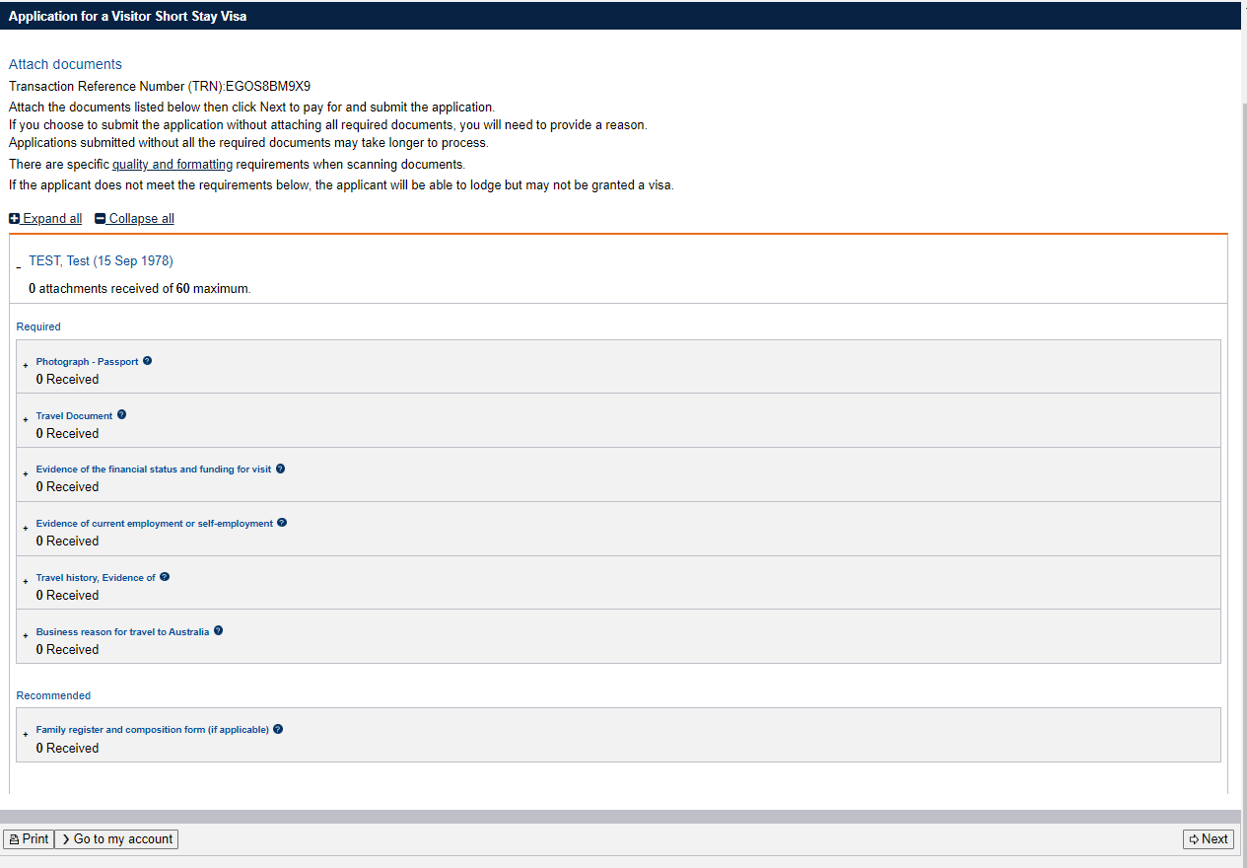

Note: If unable to attach all documents, click on ‘Next’ button and on the pop up screen provide a reason why the documentation has not been attached.
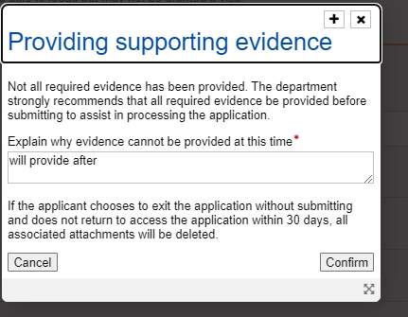

You can now pay and submit the visa application for processing .

It is important to note that the Department of Home Affairs may decide the visa application with the information provided at the time it is lodged, so it is recommended that you provide all the required documentation when submitting a visa application.

